16.57: a) The second distance is midway between the first and third, and if there are no other distances for which resonance occurs, the difference between the first and third positions is the wavelength 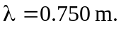 (This would give the first distance as 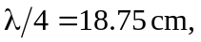 but at the end of the pipe, where the air is not longer constrained to move along the tube axis, the pressure node and displacement antinode will not coincide exactly with the end). The speed of sound in the air is then
b) Solving Eq. (16.10) for 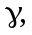

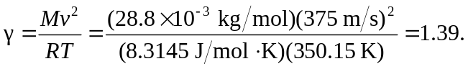

c) Since the first resonance should occur at 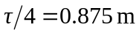but actually occurs at 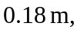the difference is 